

Chefmaster Water Boiler
Instruction Manual

Model
HEA755 – 10ltr Water Boiler
HEA756 – 20ltr Water Boiler
HEA757 – 30ltr Water Boiler

Thank you for purchasing your Chefmaster Water Boiler. To make full use of the product please read this manual carefully before using the product and keep it safe for future reference.

Safety Tips

- If you find any damage when the product is unpacked, contact your Chefmaster supplier within 24 hours of receipt of goods
- Always position on a flat stable surface
- Repairs should always be carried out by a qualified technician
- Do not overfill this product, keep water below the MAX level
- Do not switch this product on when is it empty
- Do not move this product when it contains hot liquid
- Do not use this product outside
- Do not carry when hot
- Always switch off and unplug the unit before cleaning
- Move by holding the handles
- Always store flat and do no store products on top of it
- If the power cord becomes damaged it must be replaced by a qualified technician
- This product is not designed to be used by persons with reduced physical or mental capabilities, lack of experience or knowledge, unless they are given suitable supervision, this includes children.

Pack Contents

- 1 x Chefmaster Water Boiler

Before Using For The First Time

- Clean the interior of water boiler with warm soapy water and rinse thoroughly

Operation

- Remove all packaging including all protective plastic, from your Chefmaster Water Boiler
- Position on a flat surface
- Ensure the boiler is set to 0 and the power is switched off
- Ensure that the boiler is filled to at least half way and replace the lid
- Plug your Chefmaster Water Boiler into the mains and turn it on, the power light will come on
- Set the boiler to the desired temperature, the heating light will come on. Once the water has reached the set temperature the heating light will go off
- To serve water, place a suitable container beneath the tap
- Pull the tap towards you
- Move the tap to the closed position to stop water

Cleaning & Maintenance

- Before cleaning disconnect the water boiler from the electricity supply.
- Use warm soapy water to clean to exterior
- DO NOT submerge the water boiler in water or use water sprays to clean it
- Always clean your Chefmaster Water Boiler daily

De-scaling

In hard water area’s lime scale can build up, to de-scale the unit

- Add de-scaler and water to the water boiler as the per the instructions on the de-scaler
- Clean the interior carefully with a soft brush
- Remove the water and de-scaler solution from the water boiler
- Fill with clean water and flush the boiler thoroughly to remove and residue
- The boiler is now ready to use
- Chefmaster recommend that the boiler is de-scaled every 3 months
FAILURE TO DE-SCALE THIS BOILER MAY CAUSE DAMAGE, THIS IS NOT COVERED BY THE WARRANTY

Troubleshooting

Fault | Possible Cause | Solution
The power indicator light is not on | The unit is not switched on  The plug or lead are damaged  The fuse has blown | Check the unit is plugged in and switched on  Contact your Chefmaster distributor  Replace the fuse
There is leak from the tap | Loose tap | Tighten the tap handle
The unit is on, water is not heating | Thermostat is too low  The heating element has failed | Adjust thermostat  Contact your Chefmaster distributor

Transportation and Storage

Please handle your water boiler with care to prevent any damage to the unit and internal parts. The water boiler should be stored somewhere which is ventilation and non-corrosive gas.
Do not store any flammable objects near the equipment.

Technical Information

HEA755 – 10ltr water boiler
Voltage ~230v 50/60Hz
Power 2.6Kw
Weight 3kg
Dimensions 210 dia x 475

HEA756 – 20ltr water boiler
Voltage ~230v 50/60Hz
Power 2.6Kw
Weight 4.2kg
Dimensions 268 dia x 600

HEA757 – 30ltr water boiler
Voltage ~230v 50/60Hz
Power 2.6Kw
Weight 6.2kg
Dimensions 385 dia x 500

- Chefmaster Water Boilers are supplied with a 3 pin plug and lead with a 13 amp fuse
- Appliance must be earthed
- If in doubt contact a qualified electrician or your Chefmaster distributor

Disposal

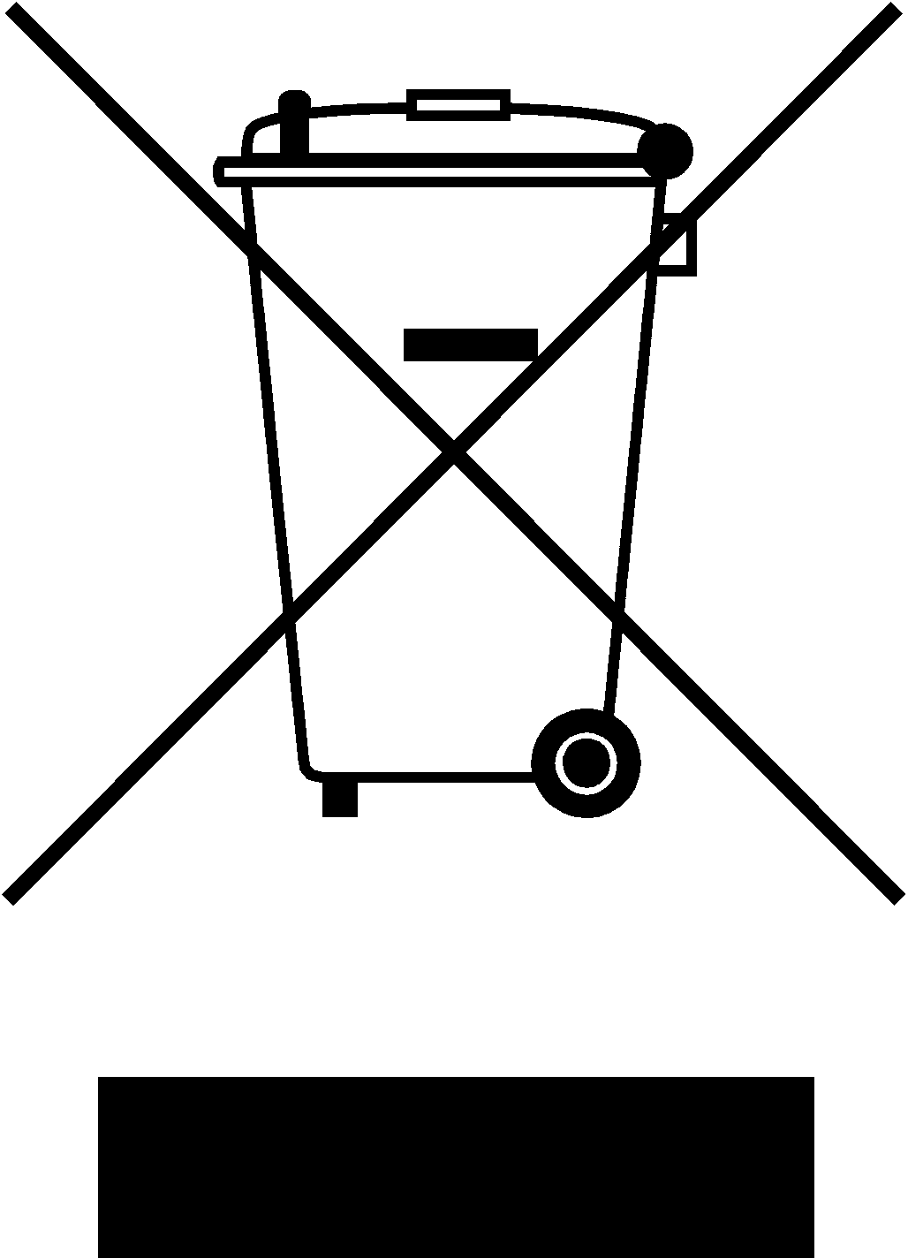

Under WEEE regulations this product must not be disposed of as household waste. To prevent damage to the environment and humans this product must be disposed of in an approved and environmentally friendly recycling process. For more information on how to dispose of this correctly please contact your Chefmaster distributor or local authority responsible for waste disposal.

Compliance


All Chefmaster parts and products have under gone a stringent testing process to ensure that comply with all European standards and specifications.
All Chefmaster products carry the CE approval symbol.

