

Chefmaster Waffle Iron
Instruction Manual

Models
HEB081 – Waffle Iron

Thank you for purchasing your Chefmaster Waffle Iron. To make full use of the product please read this manual carefully before using the product and keep it safe for future reference.

Safety Tips

- If you find any damage when the product is unpacked, contact your Chefmaster supplier within 24 hours of receipt of goods
- Always position on a flat stable surface
- Repairs should always be carried out by a qualified technician
- Do not use this product outside
- Do not carry when hot
- Always switch off and unplug the unit before cleaning
- Move by holding the product by the base
- Always store flat and do no store products on top of it
- If the power cord becomes damaged it must be replaced by a qualified technician
- This product is not designed to be used by persons with reduced physical or mental capabilities, lack of experience or knowledge, unless they are given suitable supervision, this includes children.

Pack Contents

- 1 x Chefmaster Waffle Iron
- 1 x Fork

Before Use

- Remove all packaging including all protective plastic, from your Chefmaster Waffle Iron
- Wash the plates then dry thoroughly
- Position on a flat surface
- Plug your Chefmaster Waffle Iron into the mains
- The iron will now be ready to turn on

Operation

- Ensure the iron is plugged in and the power is on
- Select the temperature you require, the heating indicator light will be on
- The heating light will cycle on and off during use
- Once the iron has reached the desired temperature the heating light will go out and the green power light will come on
- Coat the plates with vegetable oil, then add the waffle mixture
Note: This unit has a re-set button on the base. If the temperature of the unit is too high, it will cut out. Please wait for the unit to cool down, press the re-set button and the unit will function as normal.

Cleaning & Maintenance

- Before cleaning disconnect the iron from the electricity supply. Whilst the plates are still warm wash them with warm soapy water and rinse with clean water
- All parts of the iron can be cleaned with a damp cloth
- DO NOT submerge the iron in water or use water sprays to clean it
- Always clean your Chefmaster Waffle Iron daily, this will stop grease building up and becoming difficult to clean.
- Take care using metal utensils as they can damage the iron surface

Troubleshooting

Fault | Possible Cause | Solution
The plates are not heating when the power and heating indicator are both on | Temperature controller may be broken  At least one of heating wires may have burnt out | Contact your Chefmaster distributor  Contact your Chefmaster distributor
When the power is on and temperature controller is switched and heating indicator is on and temperature cannot be controlled | The thermostat may need to be replaced | Contact your Chefmaster distributor
Indicator is not on when the power is on and the iron is heating | Power indicator light may need to be replaced | Contact your Chefmaster distributor
The power is switched on but the unit is not heating | The fuse may need to be replaced | Change the fuse

Transportation and Storage

Please handle your waffle iron with care to prevent any damage to the unit and internal parts. The waffle iron should be stored somewhere which is ventilation and non-corrosive gas.

Do not store any flammable objects near the equipment.

Technical Information

HEB081 – Waffle Iron
Voltage ~230v 50/60Hz
Power 1.5Kw
Weight 20.5 kg
Dimensions 461 x 322 x 222 mm

- Chefmaster Waffle Iron are supplied with a 3 pin plug and lead with a 13 amp fuse
- Appliance must be earthed
- If in doubt contact a qualified electrician or your Chefmaster distributor

Disposal

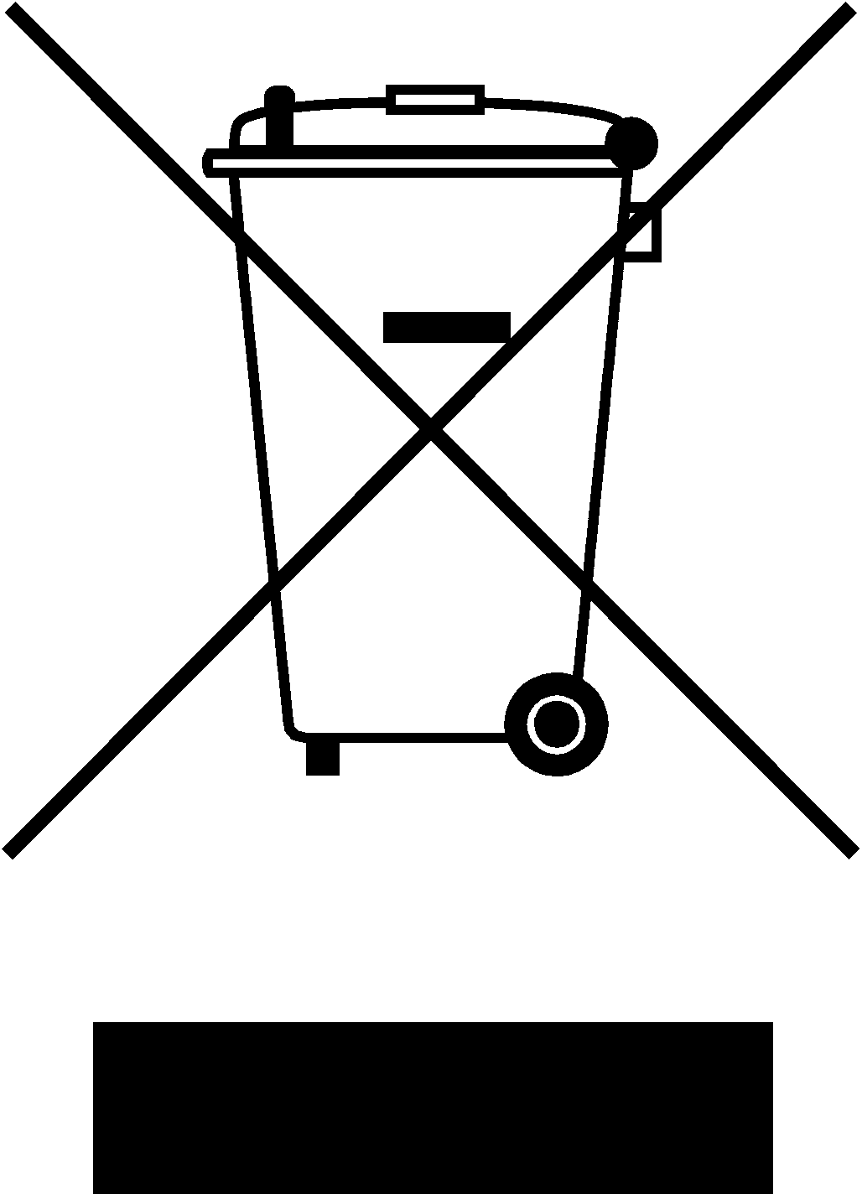

Under WEEE regulations this product must not be disposed of as household waste. To prevent damage to the environment and humans this product must be disposed of in an approved and environmentally friendly recycling process. For more information on how to dispose of this correctly please contact your Chefmaster distributor or local authority responsible for waste disposal.

Compliance


All Chefmaster parts and products have under gone a stringent testing process to ensure that comply with all European standards and specifications.
All Chefmaster products carry the CE approval symbol.

