

Chefmaster Fryer
Instruction Manual

Models
HEA752 – 6ltr Single
HEA753 – 2 x 6ltr Double

Thank you for purchasing your Chefmaster Fryer. To make full use of the product please read this manual carefully before using the product and keep it safe for future reference.

Safety Tips

- If you find any damage when the product is unpacked, contact your Chefmaster supplier within 24 hours of receipt of goods
- Always position on a flat stable surface
- Repairs should always be carried out by a qualified technician
- Do not use this product outside
- Clean immediately if oil/fat comes into contact with plastic components
- Ensure the oil level is between the MIN and MAX marks
- Change oil regularly
- Do not carry when hot
- Always switch off and unplug the unit before cleaning
- Do not cover the pan whilst frying
- Move by holding the product by the base
- Always store flat and do no store products on top of it
- If the power cord becomes damaged it must be replaced by a qualified technician
- This product is not designed to be used by persons with reduced physical or mental capabilities, lack of experience or knowledge, unless they are given suitable supervision, this includes children.

Pack Contents

- 1 x Chefmaster Fryer
- 1 x Fry basket (HEA752) 2 x Fry baskets (HEA753)

Before Use

- Remove all packaging including all protective plastic, from your Chefmaster Fryer
- Position on a flat surface
- Ensure the basket handle is securely in place
- Plug your Chefmaster Fryer into the mains
- The fryer will now be ready to turn on

Important Note: The Double Deep Dryer HEA753 comes with two plugs and separate control panels. Please DO NOT connect the plugs to the same socket with multi socket adaptor.

Operation

- Ensure the fryer is plugged in and the power is on
- Select the temperature you require, the yellow heating indicator light will start flashing
- Once the fryer has reached the desired temperature the yellow heating light will go out and the fryer is ready to use

Cleaning & Maintenance

- Before cleaning disconnect the fryer from the electricity supply.
- Once the unit has cooled down, the heating element can ne removed and the fryer pan can also be removed for cleaning
- All other parts of the fryer can be cleaned with a damp cloth
- DO NOT submerge the fryer in water or use water sprays to clean it
- Always clean your Chefmaster fryer daily, this will stop grease building up and becoming difficult to clean.

Troubleshooting

Fault | Possible Cause | Solution
The power indicator light is not on | The unit is not switched on  The plug or lead are damaged  The fuse has blown | Check the unit is plugged in and switched on  Contact your Chefmaster distributor  Replace the fuse
The unit is on, oil is not heating | Thermostat is too low  Check oil level  The heating element has failed | Adjust thermostat  Add more oil if necessary  Contact your Chefmaster distributor
The fryer heats up but the indicator light is not on | Indicator light may need to be replaced | Contact your Chefmaster distributor

Transportation and Storage

Please handle your fryer with care to prevent any damage to the unit and internal parts. The fryer should be stored somewhere which is ventilation and non-corrosive gas.

Do not store any flammable objects near the equipment.

Technical Information

HEA752 – 6ltr Single Fryer
Voltage ~230v 50/60Hz
Power 2.5Kw
Weight 5kg
6ltr single tank fryer
Dimensions 265 x 430 x 295

HEA753 – 2 x 6ltr Double Fryer
Voltage ~230v 50/60Hz
Power 2 x 2.5Kw
Weight 11kg
2 x 6ltr single tank fryer
Dimensions 550 x 430 x 295

- Chefmaster Fryer are supplied with a 3 pin plug and lead with a 13 amp fuse
- Appliance must be earthed
- If in doubt contact a qualified electrician or your Chefmaster distributor

Disposal

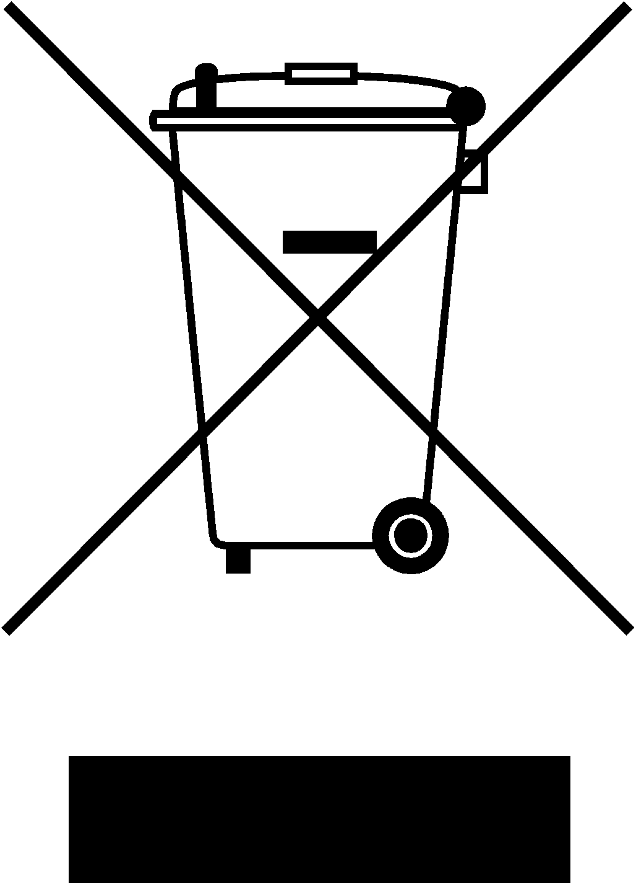

Under WEEE regulations this product must not be disposed of as household waste. To prevent damage to the environment and humans this product must be disposed of in an approved and environmentally friendly recycling process. For more information on how to dispose of this correctly please contact your Chefmaster distributor or local authority responsible for waste disposal.

Compliance


All Chefmaster parts and products have under gone a stringent testing process to ensure that comply with all European standards and specifications.
All Chefmaster products carry the CE approval symbol.

