

Chefmaster Stick Blender 750W
Instruction Manual

Model

HEA505 – Stick Blender 750W
OE9766 – Shaft 370mm for HEA505
OE9767 – Shaft 450mm for HEA505
OE9768 – Shaft 530mm for HEA505
OE9769 – Whisk for HEA505

Thank you for purchasing your Chefmaster Stick Blender. To make full use of the product please read this manual carefully before using the product and keep it safe for future reference.

Safety Tips

- If you find any damage when the product is unpacked, contact your Chefmaster supplier within 24 hours of receipt of goods
- Repairs should always be carried out by a qualified technician
- Do not remove food debris from the product until the blade has come to a complete stop
- Do not use this product outside
- Do not apply extra devices / accessories that are not supplied along with the appliance.
- Always keep the motor away from food. Do not immerse the shaft / whisk completely into the food stuffs
- Always switch off and unplug the unit before cleaning
- If the power cord becomes damaged it must be replaced by a qualified technician
- This product is not designed to be used by persons with reduced physical or mental capabilities, lack of experience or knowledge, unless they are given suitable supervision, this includes children.

Pack Contents

- 1 x Chefmaster Stick Blender
- 1 x Stick Blender Shaft 370mm (Optional)
- 1 x Stick Blender Shaft 450mm (Optional)
- 1 x Stick Blender Shaft 530mm (Optional)
- 1 x Stick Blender Whisk (Optional)

Assembly

- Remove all packaging including all protective plastic, from your Chefmaster Stick Blender
- Attach the shaft / whisk to the motor & lock by tighten up the plastic sleeve in clockwise direction
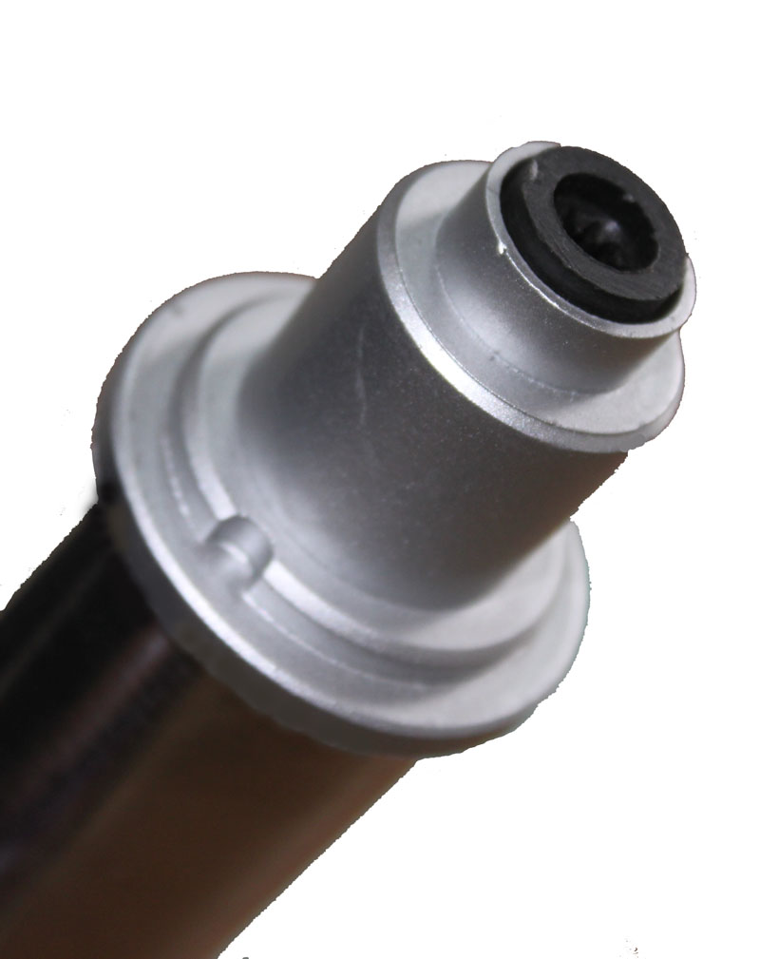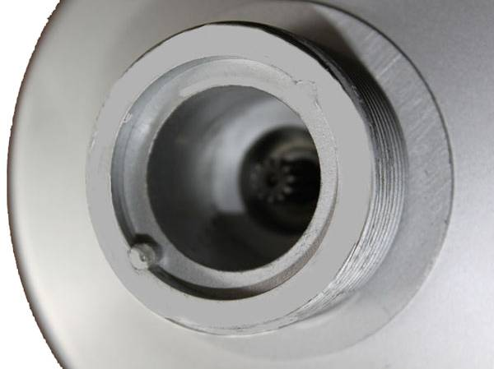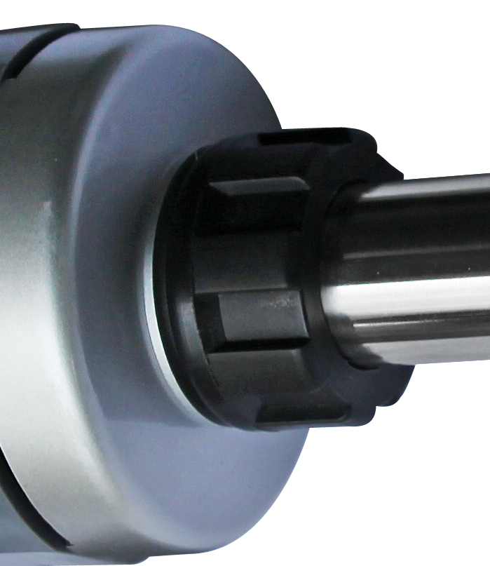
- Connect to the power supply

Operation
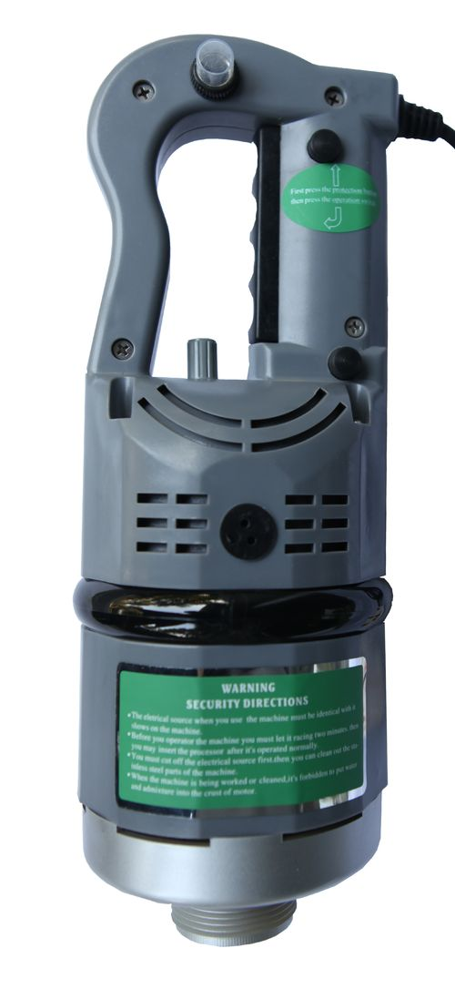  A  C  B  D  E | A: protection button  B: operation button  C: position limit button  D: manual reset button  E: variable speed
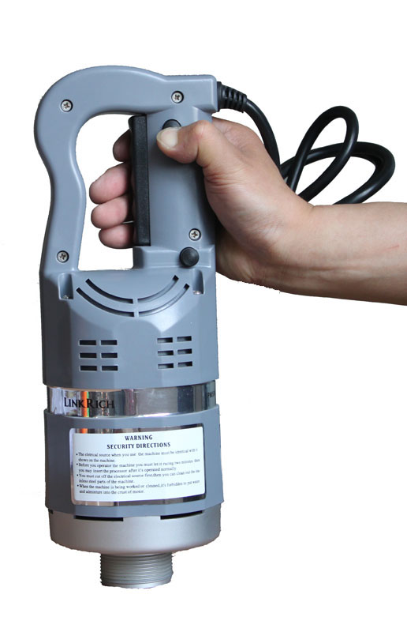
Step 1
Hold the handle with one hand, press & hold button A (Protection Button) with thumb

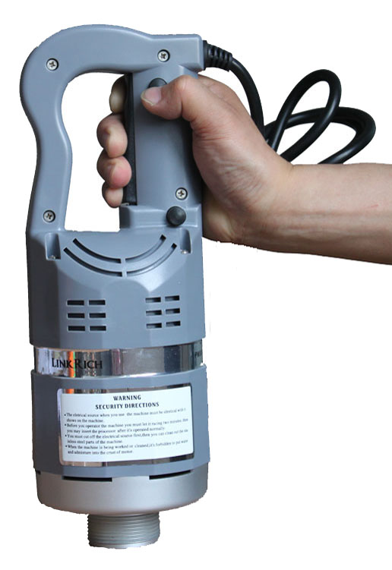 | Step 2  Press & hold button B (Operating Switch) with the rest of fingers. The blender will begin to run.
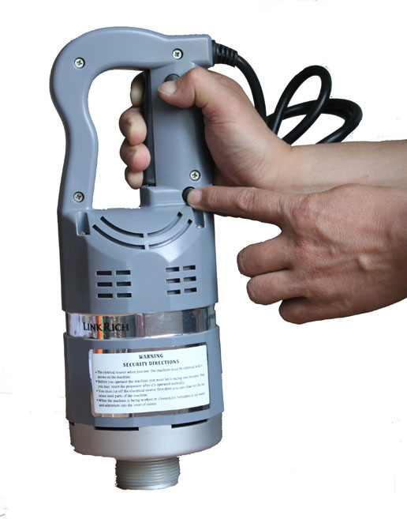 | Step 3  Press button C (Position Limit) with another hand whilst button A & B are being pressed. Release all buttons, and the blender will keep running.
Step 4
Adjust button E (Variable Speed) to preset the speed.

Step 5
To stop, press button B once

- In case overload protection is triggered, the blender will stop automatically. Press button D (Manual Reset) to restore the original state
- Always use your Chefmaster Stick Blender in the vertical position
- Warm up the product for 30 seconds (ideally 2 minutes) before food processing
- If the product operates consecutively for 20 minutes which is the maximum working time, turn it off for 30 minutes before it is used again. (20 MIN ON / 30 MIN OFF)
Cleaning & Maintenance

- Before cleaning disconnect the stick blender from the electricity supply
- Be very careful when touching the blade – It is extremely sharp
- A Wet cloth can be used to clean the shaft. Do not submerge the shaft completely in water
- DO NOT submerge the stick blender housing in water or use water sprays to clean it
- Dry the product thoroughly and keep it in a dry place
- Always clean your Chefmaster Stick Blender daily

Troubleshooting

Fault | Possible Cause | Solution
The unit is plugged in but not working | Protection button is not pressed & held before the operation switch is pressed  The plug or lead are damaged  Carbon brush is worn out  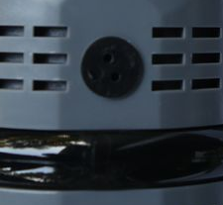  The fuse has blown | Hold the protection button and press the operation switch  Contact your Chefmaster distributor  Contact your Chefmaster distributor  Replace the fuse
The unit stops running during operation | The plug / lead / fuse are damaged  Overload protection was triggered | Contact your Chefmaster distributor / Replace the fuse  Press the manual reset button to restore

Transportation and Storage

Please handle your stick blender with care to prevent any damage to the unit and internal parts. The stick blender should be stored somewhere which is ventilation and non-corrosive gas.
Do not store any flammable objects near the equipment.
Technical Information

HEA505 – Stick Blender
Voltage 220V~240V, 50/60Hz
Power 750watt
Speed 3,000 – 12,000 rpm
Weight 2.9kg, Dimensions 110 x 110 x 325 mm

OE9766 – Shaft 370mm
Weight 0.9kg, Dimension 90 x 90 x 390 mm

OE9767 – Shaft 450mm
Weight 1.1kg, Dimension 90 x 90 x 460 mm

OE9768 – Shaft 530mm for HEA505
Weight 1.2kg, Dimension 90 x 90 x 535 mm

OE9769 – Whisk for HEA505
Weight 1.1kg, Dimension 115 x 70 x 380 mm

- Chefmaster Stick Blenders are supplied with a 3 pin plug and lead with a 13 amp fuse
- Appliance must be earthed
- If in doubt contact a qualified electrician or your Chefmaster distributor

Disposal

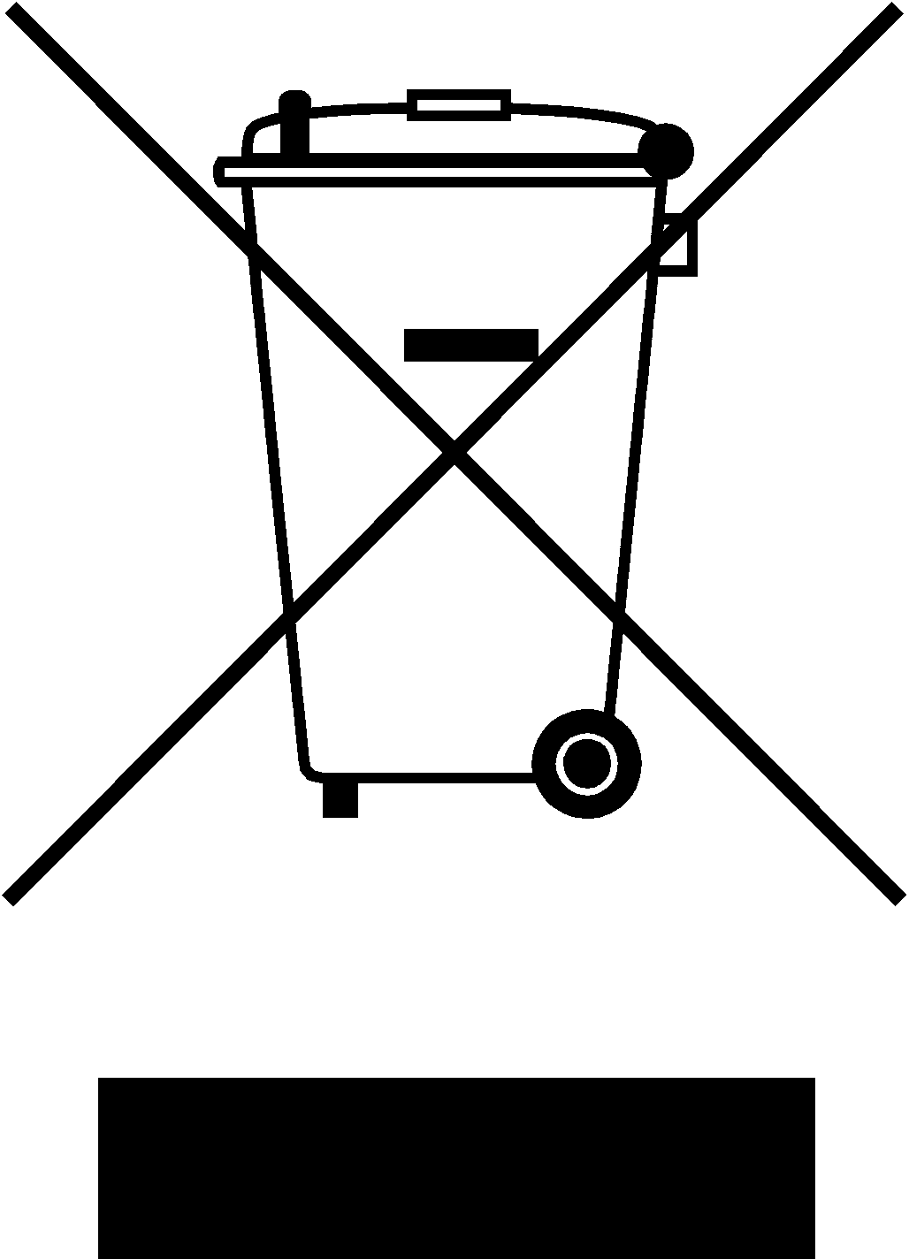

Under WEEE regulations this product must not be disposed of as household waste. To prevent damage to the environment and humans this product must be disposed of in an approved and environmentally friendly recycling process. For more information on how to dispose of this correctly please contact your Chefmaster distributor or local authority responsible for waste disposal.

Compliance


All Chefmaster parts and products have under gone a stringent testing process to ensure that comply with all European standards and specifications.
All Chefmaster products carry the CE approval symbol.

