

Chefmaster 3 Shelf Convection Oven
Instruction Manual

Models

HEC820

Thank you for purchasing your Chefmaster Convection Oven. To make full use of the product please read this manual carefully before using the product and keep it safe for future reference.

Door Handle
Heating Indicator

Thermostat Knob

Timer Indicator
Timer Knob

Safety Tips

- If you find any damage when the product is unpacked, contact your Chefmaster supplier within 24 hours of receipt of goods
- Always position on a flat stable surface and do not place any item on top of the convection oven
- Do not place the oven where the mains lead could fall into a sink
- Repairs should always be carried out by a qualified technician
- DO NOT submerge this product in water
- Do not use direct jets/ high pressure water/ jet-clean-spray to clean this product.
- Do not use the oven outdoors or place it in environments where there is open fire such as gas stove or kerosene stove in use
- Always switch off or unplug the unit before cleaning
- Always plug into a grounded outlet. Do not use an adapter or an extension cord.
- If the power cord becomes damaged it must be replaced by a qualified technician
- This product is not designed to be used by persons with reduced physical or mental capabilities, lack of experience or knowledge, unless they are given suitable supervision, this includes children

Pack Contents

- 1 x Chefmaster Convection Oven
- 3 x Removable Oven Shelf
- 1 x Drip Tray
- 1x Manual

Before Use

- Remove all packaging including all protective plastic, from your Chefmaster Convection Oven
- Position on a flat surface
- Wipe the oven chamber thoroughly with soft damp cloth only. The drip tray and oven shelves can be wiped or rinsed
- Plug your Chefmaster Convection Oven into the mains
- Operate the oven for approximately 30 minutes at the temperature 200°C to remove any odour which may be emitted. This is due to oil used during manufacture or from the oven insulation, but is not harmful.

Operation

- Open the oven door and place food on the shelf directly or with food container, then close the door
- Select the required temperature (50-250°C) with the upper dial and time (Max. 120mins) with the lower dial, the green indicators will be on

Note: Both Thermostat and Timer dials need to set up for the oven to heat up. The oven stops heating once the Time dial is in “0” position

Tips: To preheat the oven before cooking, set temperature at 200°C for 10mins

- Once the oven has reached the desired temperature the green heating indicator will turn off
- When temperature lowers, the heating indicator will be on and the oven will heat up automatically until either the timer dial or temperature dial is turned to “0” position
- When timer dial returns to “0” position, the bell rings and the green lights turn off. The food is now ready to take out

Caution: Be careful of hot air when the door is opened. Always use heat-resisted gloves to take out the food

Cleaning & Maintenance

- Before cleaning disconnect the oven from the power supply. Wash the shelves with warm soapy water and rinse with clean water
- All other parts of the oven can be cleaned with a damp cloth
- DO NOT submerge the oven in water or use water sprays to clean it
- Always clean your Chefmaster Convection Oven daily to avoid grease building up
- Use only non-abrasive cleaners and pads. Abrasive cleaners and scouring pads could scratch the finish of the oven

Troubleshooting

Condition | Possible Cause | Solution
The unit is plugged in, but power indicator is not on and the unit is not working | 1. The unit is not switched on  2. The plug or lead are damaged  3. The fuse has blown | 1. Check the unit is correctly plugged in and switched on  2. Contact your Chefmaster distributor  3. Replace the fuse
The oven is not heating when both heating and timer indicators are both on | 1. Temperature controller may be broken  2. At least one of heating wires may have burnt out | 1. Contact your Chefmaster distributor  2. Contact your Chefmaster distributor
When the power is on/ timer & temperature controller are switched and heating indicators are on, temperature cannot be controlled | The thermostat may need to be replaced | Contact your Chefmaster distributor
Indicator(s) is not on when the power is on and the unit is heating | Power indicator light may need to be replaced | Contact your Chefmaster distributor

Transportation and Storage

Please handle your oven with care to prevent any damage to the unit and internal parts. The product should be located in a well ventilated area.

Do not store any flammable objects near the equipment.

Technical Information

HEC820 – Chefmaster 3 Shelf Convection Oven

Voltage ~230v 50Hz
Power 2.5Kw
Weight 16.5kg
Dimensions 530 x 450 x 315 MM

- Chefmaster Convection Oven is supplied with a 3 pin plug and lead with a 13 amp fuse
- Appliance must be earthed
- If in doubt contact a qualified electrician or your Chefmaster distributor

Disposal

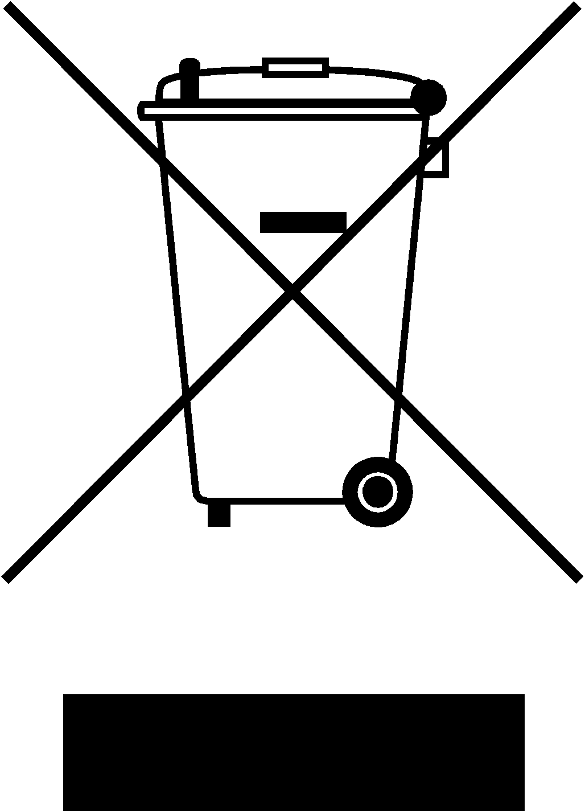

Under WEEE regulations this product must not be disposed of as household waste. To prevent damage to the environment and humans this product must be disposed of in an approved and environmentally friendly recycling process. For more information on how to dispose of this correctly please contact your Chefmaster distributor or local authority responsible for waste disposal.

Compliance


All Chefmaster parts and products have under gone a stringent testing process to ensure that comply with all European standards and specifications.
All Chefmaster products carry the CE approval symbol.

