

Chefmaster Griddle
Instruction Manual

Models
HEA754 – Smooth plate griddle

Thank you for purchasing your Chefmaster Griddle. To make full use of the product please read this manual carefully before using the product and keep it safe for future reference.

Safety Tips

- If you find any damage when the product is unpacked, contact your Chefmaster supplier within 24 hours of receipt of goods
- Always position on a flat stable surface
- Repairs should always be carried out by a qualified technician
- Do not use this product outside
- Clean immediately if oil/fat comes into contact with plastic components
- Do not carry when hot
- Always switch off and unplug the unit before cleaning
- Move by holding the product by the base
- Always store flat and do no store products on top of it
- If the power cord becomes damaged it must be replaced by a qualified technician
- This product is not designed to be used by persons with reduced physical or mental capabilities, lack of experience or knowledge, unless they are given suitable supervision, this includes children.

Pack Contents

- 1 x Chefmaster Griddle
- 1 x Drip Tray

Before Use

- Remove all packaging including all protective plastic, from your Chefmaster Griddle
- Position on a flat surface
- Ensure the drip try is correctly positioned
- Plug your Chefmaster Griddle into the mains
- The Griddle will now be ready to turn on

Using For The First Time

- Ensure the griddle plate is clean
- Brush with cooking oil
- Set thermostat to a low setting
- When desired temperature is reached the heating light will go off
- Turn off the griddle, allow to cool then wipe off oil

Operation

- Ensure the griddle is plugged in and the power is on
- Select the temperature you require, the yellow heating indicator light will be on
- Once the griddle has reached the desired temperature the yellow heating light will go out

Cleaning & Maintenance

- Before cleaning disconnect the griddle from the electricity supply
- Remove the drip tray and clean in warm soapy water
- All other parts of the griddle can be cleaned with a damp cloth
- DO NOT submerge the griddle in water or use water sprays to clean it
- Always clean your Chefmaster Griddle daily, this will stop grease building up and becoming difficult to clean.
- Take care using the scrapper as it can damage the griddle surface

Troubleshooting

Fault | Possible Cause | Solution
The griddle is not working | Appliance may not be switched on  Fuse has blown  Internal fault | Check and switch on  Change the fuse  Contact your Chefmaster distributor
The griddle is not reaching temperature | The thermostat may need to be replaced | Contact your Chefmaster distributor
Indicator is not on when the power is on and the griddle is heating | Power indicator light may need to be replaced | Contact your Chefmaster distributor

Transportation and Storage

Please handle your griddle with care to prevent any damage to the unit and internal parts. The griddle should be stored somewhere which is ventilation and non-corrosive gas.

Do not store any flammable objects near the equipment.

Technical Information

HEA754 – Griddle
Voltage ~240v 50/60Hz
Power 3Kw
Weight 23kg
Dimensions 550 x 430 x 240

- Chefmaster Griddles are supplied with a 3 pin plug and lead with a 13 amp fuse
- Appliance must be earthed
- If in doubt contact a qualified electrician or your Chefmaster distributor

Disposal

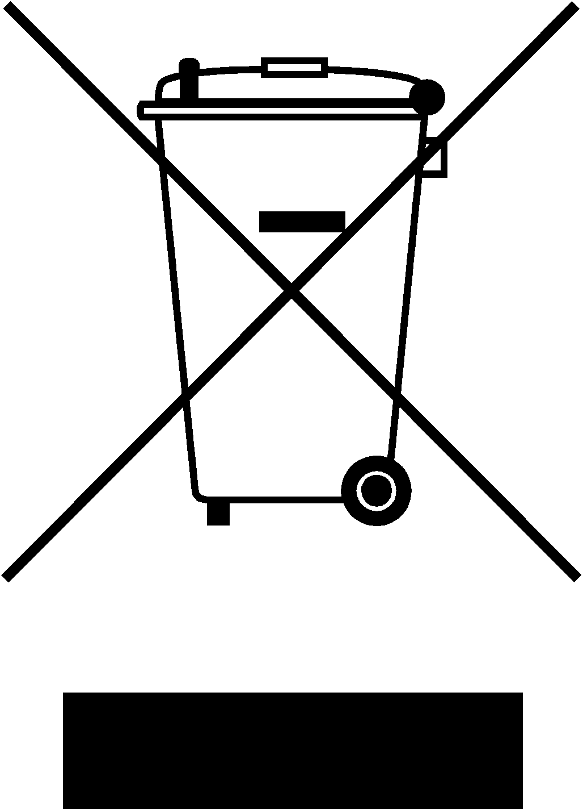

Under WEEE regulations this product must not be disposed of as household waste. To prevent damage to the environment and humans this product must be disposed of in an approved and environmentally friendly recycling process. For more information on how to dispose of this correctly please contact your Chefmaster distributor or local authority responsible for waste disposal.

Compliance


All Chefmaster parts and products have under gone a stringent testing process to ensure that comply with all European standards and specifications.
All Chefmaster products carry the CE approval symbol.

