

Chefmaster 5.5ltr Mixer
Instruction Manual

Model

HEA520

Thank you for purchasing your Chefmaster Mixer. To make full use of the product please read this manual carefully before using the product and keep it safe for future reference.

Safety Tips

- If you find any damage when the product is unpacked, contact your Chefmaster supplier within 24 hours of receipt of goods
- Repairs should always be carried out by a qualified technician
- Do not remove food debris from the product until the mixer has come to a complete stop
- Do not use this product outside
- Do not use any extra devices/accessories that are not supplied along with the appliance
- Do not insert anything into the rotating hooks whilst the mixer is in use
- Always switch off and unplug the unit before cleaning
- If the power cord becomes damaged it must be replaced by a qualified technician
- This product is not designed to be used by persons with reduced physical or mental capabilities, lack of experience or knowledge, unless they are given suitable supervision, this includes children

Pack Contents

- 1 x Chefmaster Mixer
- 1 x Dough Hook
- 1 x Beater
- 1 x Balloon Whisk
- 1 x Splash Guard
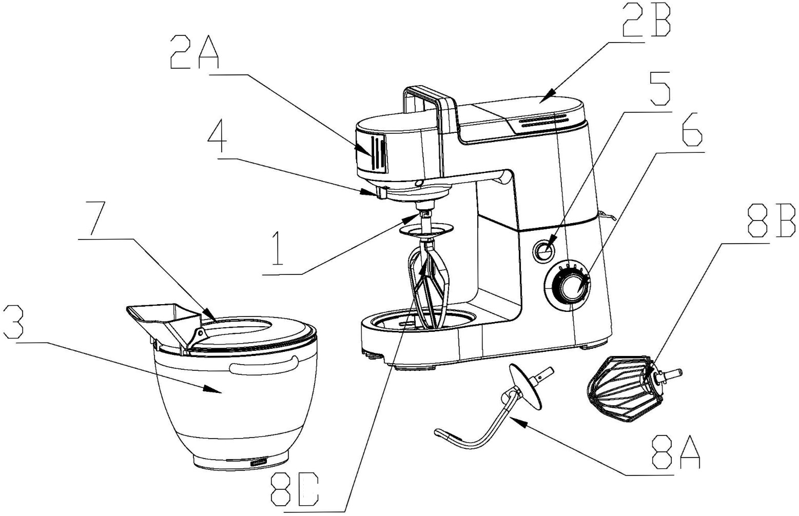

1 – Drive Shaft 2A – Front drive cover
2B – Back drive cover 3 – Mixing bowl
4 – Lock 5 – Head raising & lowering button
6 – Dial 7 – Splash guard
8A – Dough hook 8B – Balloon whisk
8C – Beater
Operation

- Raise the mixing head by pressing button 5, this will release the head and allow it to be raised
- Place the mixing bowl into the housing and twist until it locks in place
- Put the desired accessory into the drive shaft and twisting to lock into place
- Push the mixing head down until it locks into place
- Plug into the mains and select the required mixing speed on the dial, as soon as the dial is turned the mixer will start

Cleaning & Maintenance

- Before cleaning disconnect the Mixer from the electricity supply
- A wet cloth can be used to clean the mixer housing
- DO NOT submerge the Mixer in water or use water sprays to clean it
- The bowl & accessories can be cleaned in hot water or a dish washer
- Dry the product thoroughly and keep it in a dry place
- Always clean your Chefmaster Mixer daily

Troubleshooting

Fault | Possible Cause | Solution
The unit is plugged in but indication light is not on / not working | The plug or lead are damaged  The fuse has blown | Contact your Chefmaster distributor  Replace the fuse
The indication light flickers and the unit is not working | The back cover is not installed properly  The dial is not pointed to “0” when the unit is plugged in | Reinstall the back cover  Reset the dial to “0”
The mixing bowl wobbles | The mixing bowl is not locked into place | Twist the mixing bowl until it is locked into place
The unit stops running during operation | The plug / lead / fuse are damaged  Overload Heat protection is triggered | Contact your Chefmaster distributor / Replace the fuse  Remove the plug from mains. Plug in again after 20 minutes.

Transportation and Storage

Please handle your mixer with care to prevent any damage to the unit and internal parts. The mixer should be stored somewhere which is ventilation and non-corrosive gas.

Do not store any flammable objects near the equipment.

Technical Information

HEA520 – Mixer
Voltage 220V~240V, 50/60Hz
Power 1200watt
Weight 8.9kg

- Chefmaster Mixers are supplied with a 3 pin plug and lead with a 13 amp fuse
- Appliance must be earthed
- If in doubt contact a qualified electrician or your Chefmaster distributor

Disposal

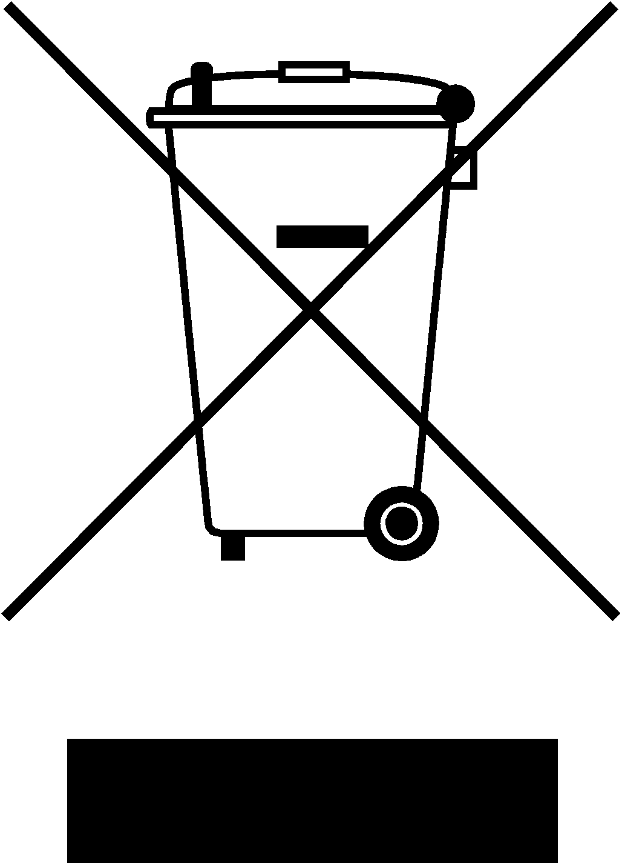

Under WEEE regulations this product must not be disposed of as household waste. To prevent damage to the environment and humans this product must be disposed of in an approved and environmentally friendly recycling process. For more information on how to dispose of this correctly please contact your Chefmaster distributor or local authority responsible for waste disposal.

Compliance


All Chefmaster parts and products have under gone a stringent testing process to ensure that comply with all European standards and specifications.
All Chefmaster products carry the CE approval symbol.

