

Chefmaster Stick Blender
Instruction Manual

Model

HEB642 – 160mm Shaft

Thank you for purchasing your Chefmaster Stick Blender. To make full use of the product please read this manual carefully before using the product and keep it safe for future reference.

Safety Tips

- If you find any damage when the product is unpacked, contact your Chefmaster supplier within 24 hours of receipt of goods.
- Repairs should always be carried out by a qualified technician.
- Do not submerge the stick blender motor in water or any other liquid.
- Do not remove food debris from the product until the blade has come to a complete stop.
- Do not use this product outside.
- Always switch off and unplug the unit before cleaning.
- If the power cord becomes damaged it must be replaced by a qualified technician.
- This product is not designed to be used by persons with reduced physical or mental capabilities, lack of experience or knowledge, unless they are given suitable supervision, this includes children.

Pack Contents

- 1 x Chefmaster Stick Blender
- 1 x Stick Blender Shaft

Product Components

Switch knob
Motor base/ Handle
Stainless Steel
Protective Blade Guard

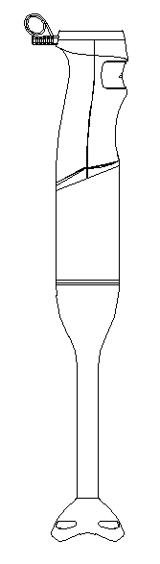

Plastic cover
Stainless Steel Shaft

Before You Begin

Before using the Chefmaster Stick Blender, suggests that you wipe the unit with a clean, damp cloth to remove any dirt or dust. Place the metal blade end of the hand blender under running water to rinse it. Dry thoroughly with a soft absorbent cloth.

Operation

- Remove all packaging including all protective plastic, from your Chefmaster Stick Blender.
- Attached the shaft to the motor unit by twisting it until its locked into place.
- Connect to the power supply.
- Push the Switch knob and your stick blender will start working. Push stronger for higher power.
- Always use your Chefmaster Stick Blender in the vertical position.
- Do not use your stick blender for more than 30 seconds at a time.

NOTE: If a piece of food becomes lodged in the protective guard surrounding the metal blade, follow the safety instructions noted below:

1. Release the power button and unplug the unit from the electrical outlet.
2. Once the power source has been disconnected, use a spatula to carefully
remove the food lodged in the blade guard. The blade is sharp. Do not use your fingers to remove lodged objects.
3. After the lodged food has been removed, plug the unit back into its power
supply and continue processing.

Cleaning & Maintenance

- Before cleaning disconnect the stick blender from the electricity supply
- Be very careful when touching the blade – It is extremely sharp.
- Clean the product with warm soapy water, the shaft can be removed and put through the dishwasher.
- DO NOT submerge the stick blender housing in water or use water sprays to clean it.
- Always clean your Chefmaster Stick Blender daily.

Troubleshooting

Fault | Possible Cause | Solution
The unit is plugged in but not working | The unit is not switched on  The plug or lead are damaged  The fuse has blown | Check the unit is plugged in and switched on  Contact your Chefmaster distributor  Replace the fuse

Transportation and Storage

Please handle your Stick Blender with care to prevent any damage to the unit and internal parts. The Stick Blender should be stored somewhere which is ventilation and non-corrosive gas.
Do not store any flammable objects near the equipment.

Technical Information

HEB642 – Stick Blender
Voltage 220~240v 50Hz
Power 800watt
Weight 0.9kg
Dimensions 75mm x 54mm x 428mm

- Chefmaster Stick Blenders are supplied with a 3 pin plug and lead with a 13 amp fuse.
- Appliance must be earthed.
- If in doubt contact a qualified electrician or your Chefmaster distributor.

Disposal

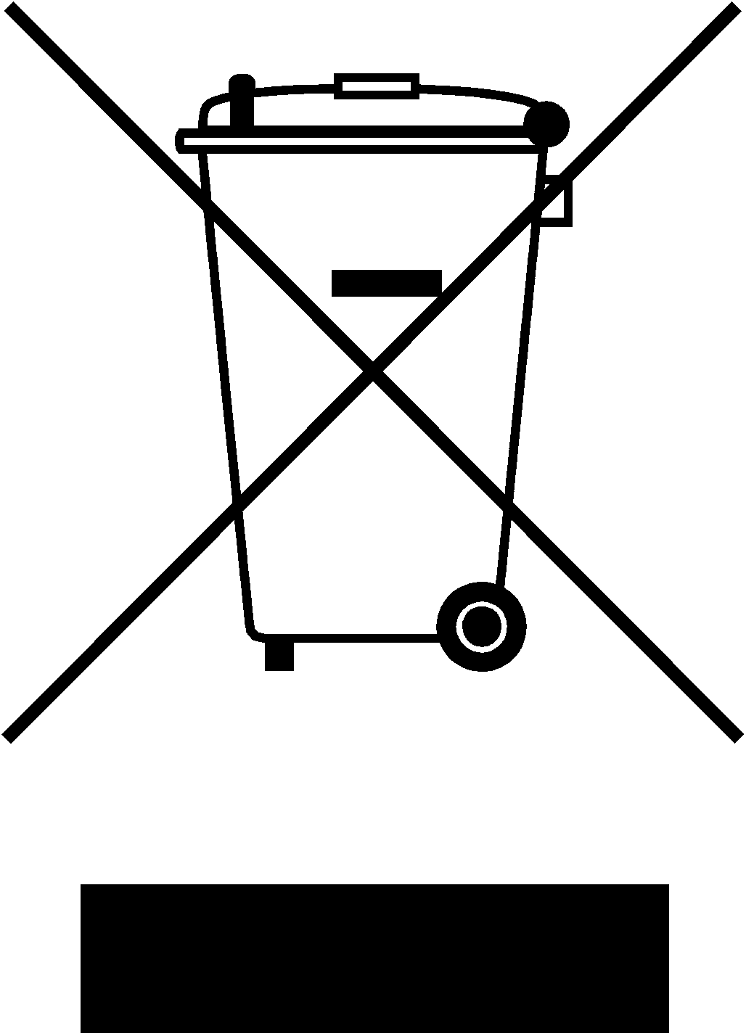

Under WEEE regulations this product must not be disposed of as household waste. To prevent damage to the environment and humans this product must be disposed of in an approved and environmentally friendly recycling process. For more information on how to dispose of this correctly please contact your Chefmaster distributor or local authority responsible for waste disposal.

Compliance


All Chefmaster parts and products have under gone a stringent testing process to ensure that comply with all European standards and specifications.
All Chefmaster products carry the CE approval symbol.

